Ryan Barber Assignment 4.2
Stika flowchart before changes
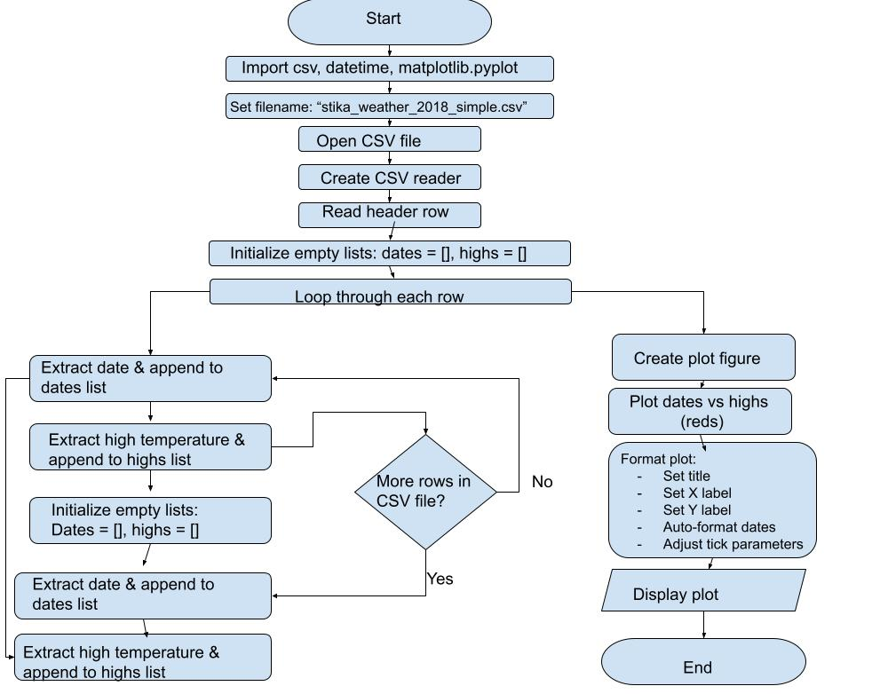
Stika flowchart after changes 